Governance models

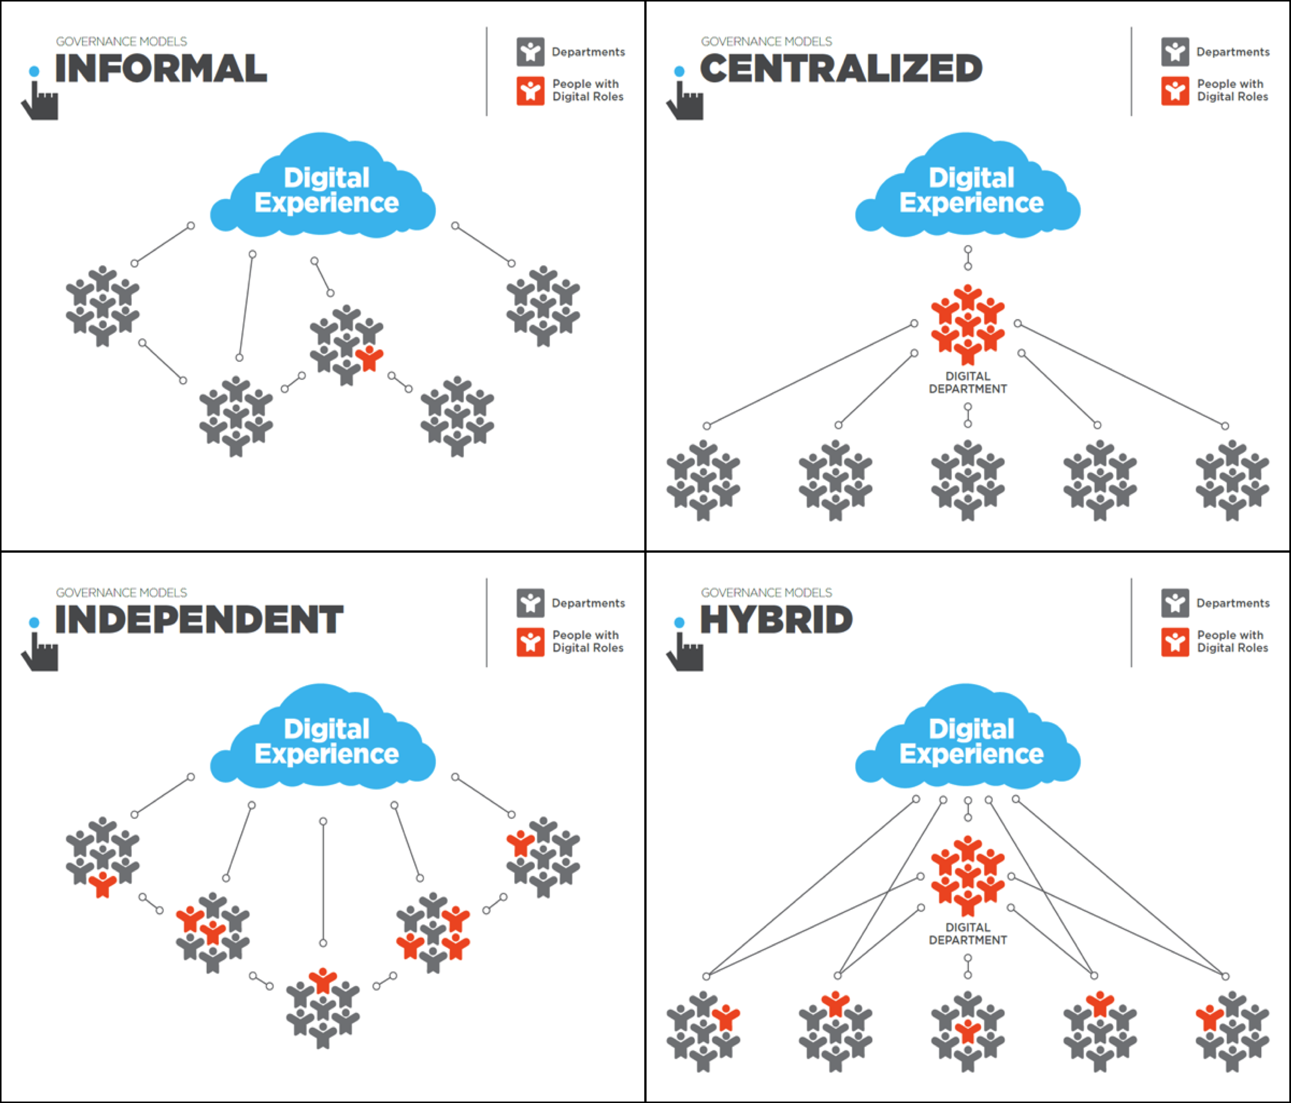

Which model does your organization use today?

Which one do you think would work best in the long run? Why?

What would it take for you to put the ideal model in place?

